ORIGINAL PAPER

The manuscript should not contain the names of the authors!
In original papers, the text should not exceed: 4400 words excluding tables and references, typewritten, double-spaced, 12 points font Times New Roman, up to 30 items of literature*

*Papers exceeding the required length or the number of items of literature will be individually considered by the Editor-in-Chief.

TITLE

Summary
(150-200 words)
Background.
Material and methods.
Results.
Conclusions.
Keywords: 5 keywords. Use only lower case (except with abbreviations and names). Keywords should be separated by a comma and based on MeSH: https://meshb.nlm.nih.gov

Introduction

The introduction should present the article subject and the existing research (literature review).

Aim of the work

This section should contain a clear presentation of the aims and reasons for undertaking the study.

Material and methods

This section is to clearly describe the research material. Material and methods should be described with sufficient details to allow others to replicate and build on the published results.

Results

Results, closely tied with the data included in the tables and figures, should be presented logically and consistently.
This section may be divided by subheadings. It should provide a concise and precise description of the experimental results, their interpretation, as well as the experimental conclusions that can be drawn.

Subsection

Sub-subsection
Lists look like this:
- First point;
- Second point;
- Third point.
Numbered lists can be added as follows:
- First item;
- Second item;
- Third item.
The text continues here.

Figures, Tables and Schemes

Instructions concerning tables, figures, and photographs:
- they should be provided with numbers and captions;
- they should be placed within the text;
- in addition, figures and photographs must be attached as separate xls, stg, pdf, cdr, eps, tif or jpg files;
- the same results should not be repeated in tables and figures;
- the illustrative material should be prepared in black and white or in grayscale (the journal is printed in black and white);
- symbols, e.g. arrows or stars, as well as abbreviations used in tables or figures should be clearly explained in a legend so that they are legible and comprehensible irrespective of the paper text.
If a figure or table has been developed on the basis of some other figure or table, the source should be provided. In the case of reprinting a table or figure from another publication, obtaining the publisher’s permission is necessary.

All figures and tables should be cited in the main text as Figure 1, Table 1, etc.

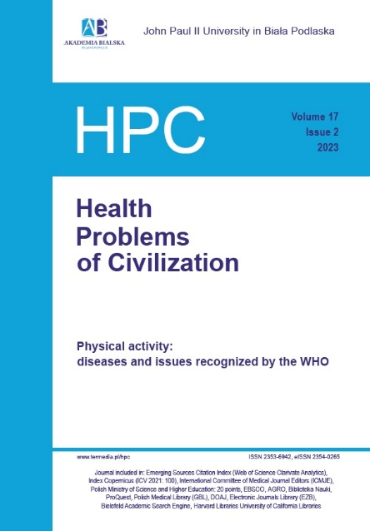
Figure 1. This is a figure. Schemes follow the same formatting. Figures should be placed in the main text near to the first time they are cited. No dot at the end of the caption
Notes: Figures may have a footer, for example with the explanation of the abbreviations used in the figure. A dot at the end of the caption

Table 1. This is a table. Tables should be placed in the main text near to the first time they are cited. No dot at the end of the caption
Title 1 | Title 2 | Title 3 | Title 4
entry 1 | data | data | data
entry 2 | data | data | data
Notes: Tables may have a footer, for example with the explanation of the abbreviations used in the table. A dot at the end of the caption

The text continues here (Figure 2 and Table 2).

a) b)
Figure 2. This is a figure. If there are multiple panels, they should be listed as: (a) Description of what is contained in the first panel; (b) Description of what is contained in the second panel.
Figures should be placed in the main text near to the first time they are cited. No dot at the end of the caption
Notes: Figures may have a footer, for example with the explanation of the abbreviations used in the figure. A dot at the end of the caption

Table 2. This is a table. Tables should be placed in the main text near to the first time they are cited. No dot at the end of the caption
Title 1 | Title 2 | Title 3 | Title 4
data | data | data | data
data | data | data | data
Notes: Tables may have a footer, for example with the explanation of the abbreviations used in the table. A dot at the end of the caption

Formatting of mathematical components

This is example 1 of an equation:
a = 1,
the text following an equation need not be a new paragraph. Please punctuate equations as regular text.

This is example 2 of an equation:
a = b + c + d
the text following an equation need not be a new paragraph. Please punctuate equations as regular text.

In numbers less than one, zero should be written before the decimal point, e.g. 0.001.

Latin binomial names of micro-organisms, plants and animals

Latin species names should be written in full the first time the name appears in text; subsequently, only use the first letter of the genus name followed by the species epithet (e.g. Escherichia coli, then E. coli). Subspecies should be italized (Corynebacterium diphtheriae subsp. mitis); groups and types should be designated by capital letters or Arabic figures (e.g. Staphylococcus aureus group A). Common names should not have an initial capital letter nor should they be underlined in the manuscript, viz. pseudomonad, salmonellas. The specific name should be given in full in the captions to tables and figures. Major ranks should be written with an initial capital (e.g. Enterobacteriaceae).

Discussion

Authors should discuss the results and how they can be interpreted from the perspective of previous studies and of the working hypotheses.

Conclusions

The original aim of the paper and the formulated hypotheses should be addressed. Vague statements and those unsupported by the research results should be avoided. Putting forward new hypotheses must be clearly emphasized.

Disclosures and acknowledgements

The author enumerates the people and institutions that contributed to the preparation of the paper, served as consultants, or provided financial or technical support.
If a conflict of interest is suspected, the author is obliged to report this in the author’s statement submitted in Editorial System while uploading initially the manuscript.

If there are no conflicts of interest, the following statement should be included:

“The authors declare no conflicts of interest with respect to the research, authorship, and/or publication of this article. The research was funded by……...”
or
“The authors declare no conflicts of interest with respect to the research, authorship, and/or publication of this article. This research received no specific grant from any funding agency in the public, commercial, or not-for-profit sectors”.

Ethical approval

All experiments employing human or animal subjects must obtain approval of an appropriate research ethics committee or the National Ethics Committee on Animal Experiments on implementing the methods suggested by the author in the experiment.
Informed consent has been obtained from all individuals included in this study. The research related to human use has been complied with all the relevant national regulations, institutional policies and in accordance the tenets of the Helsinki Declaration, and has been approved by the authors' institutional review board or equivalent committee.
The research related to animals use has been complied with all the relevant national regulations and institutional policies for the care and use of animals.
If the manuscript does not contain any study that requires human or animal ethical approval, the following statement should be included in the Disclosures and Acknowledgements section: The conducted research is not related to either human or animals use.

If artificial intelligence (AI) was not used in the creation of the manuscript, the following statement should be included:

“Artificial intelligence (AI) was not used in the creation of the manuscript.”

In case AI was used in the creation of the manuscript, the detailed description of the use of AI should be included.

Citations in the text

References should be quoted in order of citation. In the text, reference numbers should be placed in square brackets [ ] and placed before the punctuation; for example [1], [1-3] or [1,3]. At least 75% of the references should be no older than the last 3 years.
The reference list should be arranged in the order in which the citations appear in the text. If the number of authors exceed 6, after the sixth name “et al.” should be written. If the article has a DOI (Digital Object Identifier) number, please enter it at the end of the bibliographic record as a full link, e.g. https://doi.org/10.5114/hpc.2017.70524

References:

Author A, Author B, Author C. Title of the article. Name of the journal. Year; Volume(issue): pages. doi
Author A, Author B, Author C, Author D, Author E, Author F, et al. Title of the article. Name of the journal. Year; Volume(Suppl. number): pages. doi
Author A, Author B. Title of the article. Name of the journal. Year; Volume(Pt number): pages. doi
Author A, Author B, Gupta S, Author C. Title of the article. Name of the journal. Year; Volume(issue Pt number): pages. doi
Author A. Title of the article. Name of the journal. Year; Volume(issue): pages. Epub Date Year Month Day.
Author A, Author B. Title of the book. Place: Publisher; Year. p. pages.
Author A. Title of the chapter. In: Editor A, Editor B., editors. Title of the book. Place: Publisher; Year. p. pages.
Author A, Author B, Author C. Title of the article. Name of the journal. Forthcoming Year.
Author A. [Title in English / translation]. Name of the journal. Year; Volume(issue): pages (name of the original language of the publication, for example, in Polish).
Author A. Title [Internet]. Publisher; year (month day if available) [access year month day]. Available from: link to the source

